**I) MQC**

***Question 1****: A survey is conducted in a population of 7,500 subjects of whom 653 have been* diagnosed with breast cancer. The proportion 653/7,500 represents:

a. The incidence

**b. Prevalence**

c. Lethality

d. None of the above

***Question 2:*** *The standard deviation of a series of values:*

**a. Is a central measurement parameter**

**b. Is expressed in the same units as the values in the series**

**c. Has a different value if measured on a sample or in a population**

**d. Is calculated from the variance**

e. Is small when values are scattered

***Question 3:*** *The variance of a series of values:*

**a. Is a parameter used to measure the dispersion of values**

b. Is expressed in the same units as the values in the series

c. Is independent of the standard deviation

**d. Is obtained by calculating the average of the squares of the deviations from the mean**

**e. Is high when the values of the series are widely dispersed**

***Question 4:*** *In a case-control survey, the confidence interval (CI) of the odds ratio (OR) is [0.7-0.9].*

*Which of the following statements are correct? This result means that the factor studied:*

a. Does not play a role in the occurrence of the disease [**technically, a protective factor plays a role in the (non)-occurrence of the disease]**

b. Is a risk factor with a weak effect

**c. Is a protective factor**

d. May be a protective factor but is not significant

e. Invalidates the study as it lacks power

***Question 5:*** *In a study comparing the effectiveness of two types of dressings for skin wounds, the authors concluded that the performance (healing speed) of dressings A was superior to that of dressings B with a risk of error of less than 2%.*

*Question: Which of the following statements are correct? This figure of 2% corresponds:*

f. An alpha risk

**g. A beta risk**

h. A significance level p

**II) Exercises of application**

***Exercise 1:***

*During 2010, 2,346 cases of angina were identified in children under 10 years of age. The population of*

*children under 10 years of age was 16,745 on January 1, 2010 and 21,345 on January 1, 2011.*

*What is the incidence of measles in 2010 in children under 10 years of age?*

Taking into account *time spent in the population,* we calculate the **average population over 2010:**

(16745+21345) / 2 = **19045**

2346 : 19045 = x : 100000

2346*100000/19045 = **12318.19**

**Incidence rate was 12318.19 per 100000 people**

***Exercise 2:*** *Confidence interval of percentage*

*To know the frequency of scabies in a region of 250 000 inhabitants, a survey was carried out on a*

*representative sample of 4 327 persons. Among them, 913 people were found to have scabies. Calculate*

*the estimated frequency of scabies in this region and its 95% confidence interval.*

**Formula for easy by-hand caculation** = p +/- z*(√p(1-p) / n)

where:

**p**: sample proportion

**z**: the chosen z-value

**n**: sample size

Else, R can take care of it all for us.

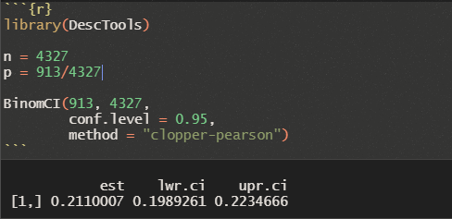

***Exercise 3:***

*The following table shows the distribution of a population in 2021 by age and gender.*

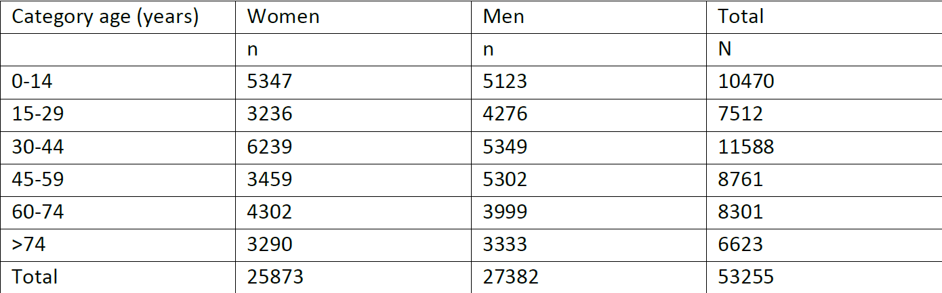

1) What is the frequency of women? **48.58%**

2) What is the frequency of subjects over 74 years old? **12.44%**

3) What is the frequency of men among 30-44 year olds? **46.16%**

4) What is the frequency of 15-29 year olds among women? **12.51%**

5) What is the ratio of females/males among subjects over 45 years old? **1 : 1.143245**